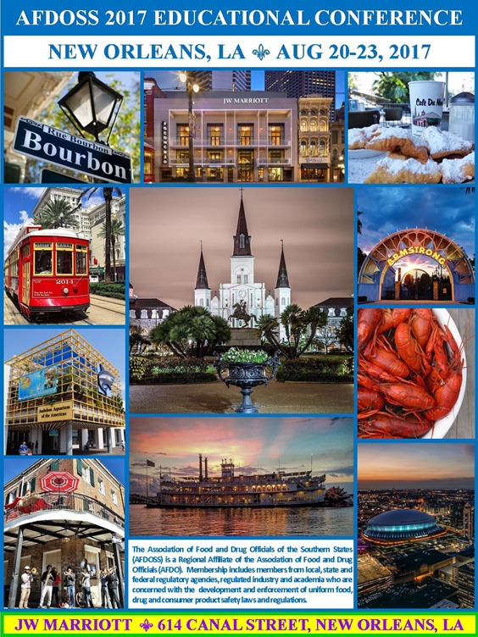
norfolk

Sunday, August 20, 2017

12:00 PM – 5:00 PM | executive board meeting - located in Royal
3:00 PM – 5:00 PM | REGISTRATION - located in Orleans maurepas alcove
6:00 PM – 8:00 PM | WELCOME RECEPTION – located in ile de france i
Monday, august 21, 2017
ORLEANS/ROSALIE/ST. CLAUDE
Moderator: Matthew Coleman, Florida Department of Agriculture
7:00 am – 8:00 am | Breakfast – Provided in the orleans/rosalie/st. claude Foyer
7:00 am - 8:15 am | Registration
8:00 am – 8:10 am | Call to Order – AFDOSS President, Brenda Morris, Florida Department of Agriculture and Consumer Services  Invocation – Rita Johnson, Florida Department of Agriculture and Consumer Services
8:10 am – 8:15 am | President’s Welcome – AFDOSS President, Brenda Morris, Florida Department of Agriculture and Consumer Services
8:15 am – 8:45 am | AFDO Updates – AFDO President, Pam Miles, Virginia Department of Agriculture and Consumer Services
8:45 am – 9:45 am | Grade “A” Dairy Plants FSMA-like State Enforcement Changes Interfacing with FDA FSMA Field Enforcement Efforts – Cooperation or Chaos? – Allen Sayler, Senior Director of Food and Cosmetic Consulting Services, EAS
9:45 am – 10:15 am | LSU AgCenter School of Nutrition and Food Sciences & Louisiana Sea Grants – Supporting the Food Industry –Evelyn Watts, Louisiana State University
10:15 am – 10:30 am | BREAK
Moderator: Eugene Evans, NY State Department of Agriculture and Markets
10:30 am – 11:15 am | Industry Listeria Guidance for Ready to Eat Foods Confirmation – Mickey Parish, FDA
11:15 am – 11:45 am | An Industry Perspective on Listeria – What has worked and what hasn’t – Bill Brodegard, Schwan’s Foods
11:45 pm – 12:30 pm | AFDO Gen-Ed Course and the National Curriculum Standards Grant - Mark Reed, AFDO
12:30 pm – 2:00 pm | LUNCH (on your own) Go Watch the total solar eclipse!
2:00 pm – 3:00 pm | Regulation of Food Products that Contain Alcohol – Katherine Simon, Minnesota Department of Agriculture
3:00 pm – 3:15 pm | BREAK
Moderator: Melissa Lombardi, Brunswick County Health Services
3:15 pm – 4:15 pm | New York Fish Sampling and Speciation – Eugene Evans, NY State Department of Agriculture and Markets
4:15 pm – 5:00 pm |  | Seafood Fraud – Ron Messa, Special Agent, NOAA Fisheries Office of Law Enforcement
5:00 pm |  | Adjourn

Tuesday, august 22, 2017
ORLEANS/ROSALIE/ST .CLAUDE
Moderator: Nikeya Thomas, Virginia Department of Agriculture and Consumer Services
7:00 am – 8:00 am | Breakfast – Provided in the orleans/rosalie/st. claude Foyer
8:00 am – 8:30 am | IFPTI Fellows Presentations  Use of Critical Control Points (CCPs) in Florida Seafood HACCP Plans - Matthew Coleman, Florida Department of Agriculture and Consumer Services  Control of Behavior-Centric Risk Factors Between Two Management Groups - Renita Stroupe, Dekalb County Board of Health
8:30 am – 9:30 am | Dude! What’s Going on With Marijuana? – Cynthia Culmo, CC Consulting and Courtland Imel, Ceutical Labs
9:30 am – 10:30 am | Use of Social Media for Foodborne Illness Surveillance - Dr. Jenine Harris, Associate Professor, Brown School, Washington University in St Louis and Kara Sewalk, Program Coordinator, HealthMap
10:30 am - 10:45 am | Break
Moderator: Mark Sestak, Alabama Department of Public Health
10:45 am – 11:30 am | Electronic Temperature Monitoring at The Kroger Co – Shana Davis & John Szymanski, Kroger
11:30 am – 12:15 pm | Vessel Sanitation – LT Scott Daly, CDC
12:15 pm – 1:15 pm | BUSINESS LUNCHEON (included with registration) – PROVIDED IN MAUREPAS
Moderator: Bess Ormond, Food and Drug Administration
1:15 pm – 2:45 pm | Boat to Throat – What are the Risks with Molluscan Shellfish – A Panel Discussion  John Veazey & Donna Wanucha, FDA  Gordon LeBlanc, LA Department of Health  Chad Hebert, LA Department of Wildlife and Fisheries  Jenna Iberg-Johnson, LA Department of Health  Jill Zednick, MS Department of Marine Resources  Jeffrey Davis, & Jessica Rankin, MS Department of Marine Resources
2:45 pm – 3:00 pm | Break
Moderator: Jessica Badour, Georgia Department of Agriculture
3:00 pm – 4:15 pm | Rapid Response Team Panel  Summer Williams, Florida Department of Agriculture and Consumer Services  Brandon Sauceda, Georgia Department of Agriculture  Queen Swayze, Mississippi State Department of Health  Angie Culler, South Carolina Department of Agriculture  Daniel Gaines, North Carolina Department of Agriculture
4:15 pm – 5:15 pm | Data Integrity – Mike Chappell, Green Leaf Health
5:15 pm |  | Adjourn

Wednesday, august 23, 2017
ORLEANS/ROSALIE/ST. CLAUDE
Moderator: Renita Stroupe, Dekalb County Board of Health
7:00 am – 8:00 am | Breakfast – Provided in the orleans/rosalie/st. claude Foyer
8:00 am – 8:30 am | Imported Food Products – Ingrid Zambrana, FDA
8:30 am – 9:45 am | Produce Safety Programs. A Panel Discussion  Kelly Johnson, South Carolina Department of Agriculture  Trevor Gilbert, FDA  Maggie Hart, Georgia Department of Agriculture  Dr. Michelle Danyluk, University of Florida
9:45 am - 10:00 am | Break
Moderator: Matthew Colson, Florida Department of Agriculture and Consumer Services
10:00 am – 10:30 am | International Food Protection Training Institute Update – Jerry Wojtala, IFPTI
10:30 am – 11:15 am | FSIS Update – Larry Hortert, FSIS
11:15 am – 11:45 am | President’s Closing Remarks – AFDOSS President, Brenda Morris, Florida Department of Agriculture
11:45 am |  | Adjourn
Don’t forget to visit the Silent Auction in Maurepas and make your bids!
The bidding will be open from the start of the conference until Tuesday, August 22nd at 5:30 pm. Thanks to everyone who brought donated items! Remember, “It’s for the kids!”

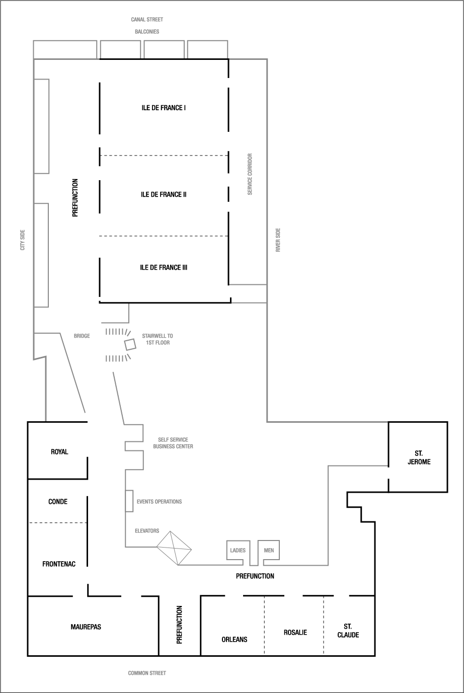
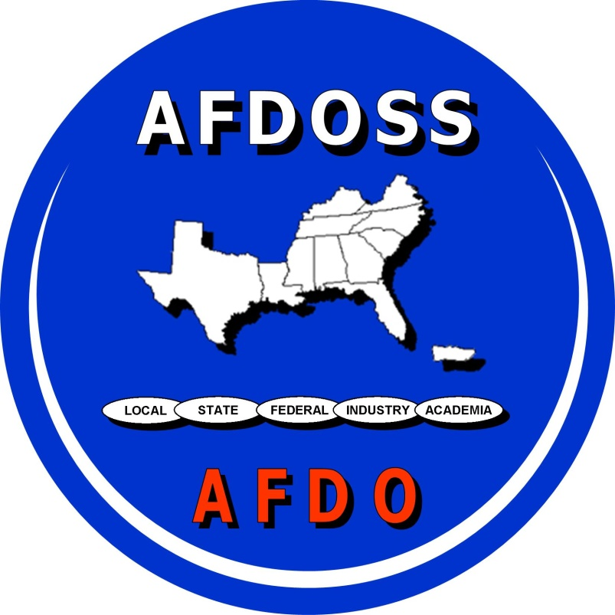
Have you explored the NEW AFDOSS website yet? www.afdoss.org
Visit & see how we’ve revitalized & updated the information shared on our site; special thanks to the AFDO staff for shifting all the information from the old site to the new platform, and for getting us set up with Wild Apricot for our membership management.

Don’t forget to “like” AFDOSS on Facebook! www.facebook.com/afdoss
Share your favorite conference photos and updates from this week, and post any of your organization/ program’s news, training opportunities, job postings, interesting articles relating to food protection, etc. anytime throughout the year!
AFDOSS would like to extend a
special thank you to:

Everyone who brought items for this year’s silent auction!

Everyone who has helped contribute
to the AFDOSS Scholarship Fund for 2017-2018.

Craig Nielsen, AFDOSS Secretary/Treasurer

See you at the Park Vista Hotel
In Gatlinburg, Tenn.
September 9-12, 2018

“Funding for this conference was made possible, in part, by the Food and Drug Administration through grant 4R13FD004160-05. The views expressed in written conference materials or publications and by speakers and moderators do not necessarily reflect the official policies of the Department of Health and Human Services; nor does any mention of trade names, commercial practices, or organization imply endorsement by the United States Government.”

Thank you!
2017 AFDOSS Agenda Sponsor

